==============================

**Overview of the game:**

Save a dying planet from the apocalypse in the Apocalypse Agency. An action RPG set in a constantly evolving Open-World. Fight for honor in this FPS and hunt “Uniques”.

Description of Gameplay: The PVE aspect of the game would be a group of players would try and defeat a high health boss, with waves of minions with the difficulty aspect of dark souls which will thus need to create a new strategy for each boss and zone environment. The customization or upgrade aspect of the game would be the guns which some would be futuristic or modern or having a fusion between the two, alongside progressively improving equipment and leveling skill trees.

Lore: In the 21st century, Some space ray hit earth and shattered the planet. The “Uniques’ appeared from the mutation and terrorised earth. The “Agency” was created with the union of all countries hiring specialized soldiers to fight back against the “Uniques” with you being one of the soldiers of the “Agency”. You will fight against the “Uniques'' and your colleges for rank and glory. With the assistance of a genius scientist, Wonstin helps adapt you and your colleagues to this new age (brings in gun mods and mutations and specialized equipment).

Target Audience: Male, 15-30, mainly for action, gore, adrenaline type games

Target Platform: Console+PC due to the need for multiple controls and hardware for smooth gameplay

Genre:

* FPS
* RPG
* Open World
* Action
* Character customization
* Adventure
* Fantasy
* Souls-like
* Atmospheric

Publishing Platform: Steam, Epic, Itch.io, Game Jolt, basically every publishing platform for pc and console games

Core Mechanics:

* Movement: Walk, Jump, Glide, Crouch, Stamina
* Attacking: Shoot, Aim, Skills(Combat type), Consumables(Grenades, etc.)
* Health: Resting(Out of Combat Regen), Consumables(stimpack, etc.), Skills(Buff types)

Dynamics:

* Movement: Running/Sprinting, Sprint+Dodge=Slide, Movement Direction+Dodge=Dodge Roll, Vaulting, Climbing, Maneuvers cost Stamina
* Attacking: Move+(Shoot,Skills,Consumables), Crouching+Aiming(increases range and accuracy), Sprint/Jump+Hip Firing, Aiming+Shoot
* Health: Walk+Resting(slow regen), OutOfCombat+Consumable=(increased healing)

Aesthetics:

* Player Customisation(Armour/Clothes). Players are able to use their creativity for their own customization(as self-discovery and expression of creativity)
* Gun Modding, can have different grips and sights to fit your playstyle, eg: more aggressive = faster reload and fire rate, slow and tactical = heavier bullets and long range scope(as creativity, self-discovery)
* Killing and attacking gives feeling of power and destruction, which includes challenges(adrenaline when completing hard tasks and sense of accomplishment when doing so)
* Running and exploration in an evolving Open-World gives player freedom of movement and obstacle management, alongside exploration(as fantasy and discovery of uncharted territory)
* Immersive game assets as decoration and map design(as sensation, fantasy, narrative)
* As challenge to find tools, areas, and map control, to fight and overcome bosses

Art Style/Design:

* Realistic open world with dynamic day/night/weather cycle, which allows players to experience a wide range of elements, making them more immersed in the game
* Fog of war, to cover up far rendered textures that look like shit
* Rural, forested, snowy / mountainous, Urban city area, Underground Caverns
* Muted almost monotone colors which provides that post apocalyptic feel, but with enough details for realism.
* Wonstin’s Science facility area, with harder monsters but better loot rewards, and requires an expensive and rare keycard to enter

Rival games: destiny 2, dauntless, monster hunter

Todo: WIP features, black market, bounty board, crafting, base/hideout,

==============================

Market Research to justify the decision to develop the game above/Rival Companies

<https://vgsales.fandom.com/wiki/Monster_Hunter>

<https://en.wikipedia.org/wiki/Monster_Hunter> //count as sales, 75 million copies, 2004

<https://screenrant.com/monster-hunter-rise-popular-system-selling-game-japan/>

<https://www.gamedeveloper.com/business/-i-monster-hunter-world-i-has-sold-over-17-1-million-copies-worldwide>

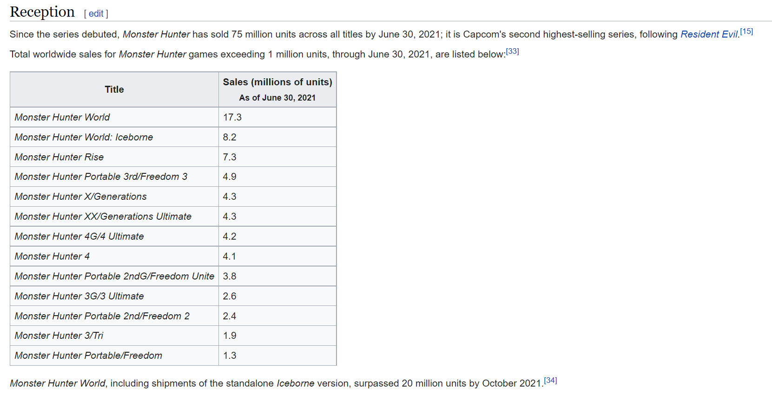

<https://ictmarketexperts.com/en/news/dauntless-with-6-million-players-within-10-days/>

EXAMPLES:

Destiny 2 is an action MMO with a single evolving world that you and your friends can join anytime, anywhere, absolutely free.

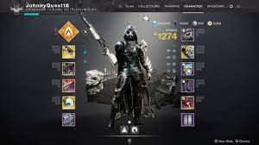

In Monster Hunter: World, you can enjoy the ultimate hunting experience, using everything at your disposal to hunt monsters in a new world teeming with surprises and excitement.

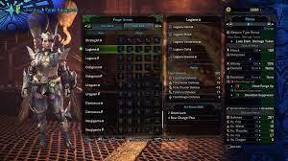

Warframe

Warframe is a cooperative free-to-play third person online action game set in an evolving sci-fi world.

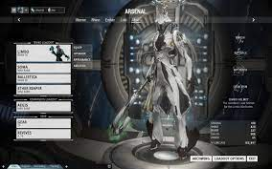

Genshin impact

Embark on a journey across Teyvat to find your lost sibling and seek answers from The Seven — the gods of each element. Explore this wondrous world, join forces with a diverse range of characters, and unravel the countless mysteries that Teyvat holds…

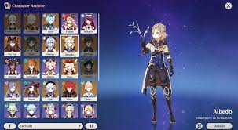

Dauntless is a free-to-play online action RPG from Phoenix Labs. Look forward to regular updates, seasonal events, new Behemoths, and more in a rich, evolving world.

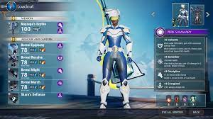

==============================

Individual Analysis: Game References/Competitors

Brief overview

Mechanics, Dynamics, Aesthetics (Types of Fun)

Risk, Rewards and Motivations

Pro and Cons

==============================

2 slides,1 minute max/person

==============================

Basil : Paladins

Overview:

A hero teamfight,MOBA,FPS based game with different heroes, with different roles in the games( tanks, frontline, flankers) with each hero having a different kind of play styles with different deck builds you are able to use. With different modes such as, escort the payload, FFA, Domination and TDM. with each round having a buy system for different builds for each character. Having a paying system for unique skins and emotes all included inside a loot box system

Pros:

Unique character design with each character having a different playstyle of different gun mechanics.

Cons:

Having many different genres the game has hardly any identity. With many bugs in the game and having a broken issue for some characters which took a long time to fix

Similar top down games include: overwatch,battleborn, team fortress 2

==============================

Winston: Dead Mage’s Children of Morta

Children of Morta is a story-driven hack & slash, with action role-playing aesthetics and roguelike elements, released in September 2019. Developed by studio Dead Mage and published by 11 bit studios, it follows the story of the Bergson family, custodians of Mount Morta, who must defend it from an evil called the Corruption.

Mechanics: 4 direction movement+dashing, stamina meter, attacking and secondary attacks, looting and killing enemies, exp and levels.

Dynamics: dashing through traps and enemy attacks. Chaining attacks allows combos and CC. Healing only using potions makes health much more important. No inventory means you cannot enter a boss fight overleveled and have consumables apart from single use runes.

Aesthetic: Fantasy, narrative, exploration, feeling of accomplishment from beating bosses and completing the dungeon.

R/R is finishing puzzles to gain souls, which can be carried on to other runs, but can also be used to buy items in the shop that change gameplay drastically. The risk is that every puzzle and “event” is highly dangerous and can end the run immediately.

However, there isn't a need to get souls to finish the game. This is similar to gold found through casual gameplay, where the whole family benefits from passive upgrades bought with the gold.

Motivation: Fantasy and Story Immersion, to play as a member of the Bergsons and follow their story. Discovering Creativity, to play a preferred character and create a “build” for them, to explore the dungeon and play different puzzles.

Pros: Enriching story line and compelling choices to make, family bond mechanic and corruption encourages players to play all members for bonuses. Unlimited replayability due to dungeon runs. Boss battles usually promote story progression alongside player growth.

Cons: repetitive gameplay after exploring each location, but unable to continue as you have not progressed the storyline yet. The game’s theme is “family” and the simplistic classes don't do it justice, making members of the bergson's just another cutout of RPG classes. There is a lack of synergy within the family that doesn't get solved within the skill tree’s level passives. While cumulative passives do boost gameplay, “calling a family member to help you” does not show anything apart from simply helping you not die during a run, while developers can simply just put in a feature that allows for team runs, where you control 1 main character while the other member has an AI that supports team alignment.

Art type: top down, 8bit and soft colors. Micro-narrative events in-line with gameplay events as well as atmospheric OST.

Similar top down games include: ”Moonlighter”, “Wizard of Legend”, “Enter the Gungeon”, “Hades”, “Curse of the Dead Gods”, “Hyper Light Drifter”, ”UnderMine”, “Katana:Zero”

Other 2d platformers games include: ”Vagante”, “Dead cells”, “Spelunky”, “Neon Abyss”, “Dungreed”

==============================

Jerryl : Phantasy Star Online 2 New Genesis (PSO2:NGS)

Description:

PSO2 NGS is the latest chapter in the Phantasy Star Online 2 series,this new adventure takes place on a vast open field! Up to 32 people can enjoy the adventure in a new world with beautifully evolved graphics!

Pros:

Fun movement mechanics (double jump, glide, run, shoot, etc)

Fun combat (Raids, bosses, etc)

Sizable areas to explore

==============================

Koh win: Escape From Tarkov

Description:

Escape from Tarkov is a hardcore and realistic online first-person action RPG/Simulator with MMO features and a story-driven walkthrough. Made by BattleState Games in 2016 and has been in beta since 2018

Lore/Story:

With each passing day, the situation in the Norvinsk region grows more and more complicated. Incessant warfare in Tarkov has sparked massive panic; the local population has fled the city, but those who stayed are looking to improve their fortunes at the expense of others. Having accepted the new reality, savage Tarkov locals - "Scavs" - flocked into well-armed gangs and started the redivision of the city. Nowadays, Tarkov is separated by unseen borders, controlled by different groups. Gain-greedy gunmen would go to any length to have their way, including the murder of civilians and direct confrontation with the two private military companies.

Gameplay features:

* Complete large-scale raids with friends or alone, exploring the many areas of the Norvinsk region, like military bases, large chemical plants, urban cities and open forests, with real-time changing weather.
* Trade and barter limited items and weapons with traders for more powerful equipment, or go to the flea market and sell or buy your own items to other real players.
* Accept quests from the traders to build your trust with them, which allows you to trade more valuable items and also insure your gear.
* Manage your hideout via putting fuel into the generator, and use the many spaces like the shooting range to test out newly crafted guns, the med station to craft health items and stimulants to give you an edge in combat, or even generate a stable income by crafting a bitcoin farm.
* Mod your guns using the most complex and in-depth weapon modding system in any game ever. All mods are based and named after real mods in the real world. Want to put an Eotech VUDU 6x24 riflescope? You require a dust cover with a rail mount, along with a 30mm ring mount just to fit it on.
* Play as your PMC or SCAV, and as a scav, get a random set of low tier gear. If you manage to extract as a SCAV, you can transfer all your gear to your PMC inventory.
* Fight other PMC’s or SCAV’s, where most scavs are bots driven by AI with an intent to kill. You can fight scav bosses and bot raiders too, which are way scarier than regular scavs.
* Beware, as if you die, all the gear you brought into the raid will be lost.

Game Mechanics:

Basic movement, shooting, reloading, all things gun-related. Inventory mechanic where you can open up your inventory to use and drop items. Item pickup mechanic where you can pick up items off the floor. Dying mechanic when your health drops to 0

Game Dynamics:

Looting dynamic where you can open containers and loot dead bodies for their gear and weapons. Hideout management where you can add fuel to generators, and craft items by collecting and using them. Flea market where you can buy and sell the items you collected.

Game Aesthetics:

Realistic looking terrain and effects, with real-life bullet ballistics, where wind, rain and type of bullet can affect its movement, makes it immersive. Tactical-like feeling as you need to have constant communication with your teammates so as to not mistake each other as enemies. Completing Quests and killing SCAV bosses gives a sense of accomplishment. Sense of fear that you might get killed and lose all the gear you brought into the raid.

Art / Gameplay style:

FPS, realistic with soft monotone colours to give that post-apocalyptic effect. Apart from the main menu OST, audio mostly consists of footsteps, shooting and weather changes like rain.

Similar games: Rust, DayZ, Dead Matter

Mechanics/dynamics/aesthetics we might reference from this game:

* Advanced weapon modification
* Hideout dynamic where you can craft items to be used to fight the monsters
* Realistic looking terrain and effects.
* AI-driven monsters.
* Lore based maps, like LABS

**SCRIPT**

**Intro:** Good Morning Teachers and Friends, We are group 203 and our game is called Apolo Agency. From the left is basil winston jerryl koh win.

**General Idea:**

Our Target Audience of the game will be 15-30 YOs and it will be a PC & Console based game.

Apocalypse Agency would be sold in PC platforms like Steam and Epic games and Common Consoles like Playstation, Xbox store and Nintendo switch.

You play as a super soldier created to fight against ‘Uniques' in a modern apocalypse, gunning down bosses in extensive maps.

**Mechanics:** There are movement, attacking, health and other mechanics that we decided to include. They are pretty similar to other rpg games, with the standard 4-directional movement and evasive maneuvers. Next, we have skills and consumables that aid attacking and survivability. And lastly, we have the inventory, map, and shop mechanics.

**Dynamics:** These are the player dynamics, which add some diversity to the playstyles employed to play the game. Such as chaining maneuvers with classic dodges. Next, we have several consumables, inventory, way points and buying/selling items.

**Aesthetics:** we chose to breathe life into the game by using sensation and challenge as our core aesthetics, similar to skyrim and dark souls. But let's not talk about those 2 today, as they are heavily influenced by fantasy. The challenging gameplay and beating up bosses, maybe even soloing some raids, makes you feel good, alongside the sensation of the sights and sounds.

**Visual Styles:**

The Visual Styles we chose for this game would be realism, it also adds more characteristic to the game as it is set in the modern world. Other than realism, we decide to have muted colours and Fog of war to set the environment to be more abandoned, giving additional feelings of fear towards the “uniques”. There will also be additional weather variety to give a feel of the character going through day by day giving it diversity and changes in gameplay making each duration in game time have a different vibe.

**Similar games: (Jerryl)**

Since the games we are creating are open world, First person, RPG, We had gone to found similar kinds of games that are successful commercially and the recent amount of players are online.

First Game we would like to mention is Monster Hunter World which was released on 26 jan 2018. Main Game is 41 SGD and the DLC is about 60USD. It is regularly on the top 10 selling games on Steam with 15 thousand active players in Oct 2021. 20 million copies were sold by Oct 2021 which shows that it is CAPCOM’s largest title, amassing 105mil in profit in 2018.

MHW started about 3 years prior to E3 2017 reveal and playable version was built within 9 months Second is destiny 2 which was released in october 2019 and has total revenue 164mil with total p[rofit of 90 mil. There are an estimated 70k players a day. 50k copies were sold in its first week on console and took 1st place in sales in the UK. It also won the game critics award for best PC game in 2017. The main game is now free.The last game is warframe which was released in march 2013, and has a total revenue of 74.1 mil usd in 2020. There is an average of 38k players active in the last 30 days and is leyou’s largest title, accounting for 80% of revenue generated in 2019.

These games are similar in the genre of open world rpg. They also have similar aesthetics and dynamics just with different execution and story.

So that is why these games are compared to ours as we feel these games are most similar to ours

**Market research:**

All these similar games have all these things in common with ours, but we need to ask, why? Why would they choose this game genre? Or why would they release it on these platforms? To answer that, we have to turn to data. So to start, let's look at which platform makes the most money. According to newzoo.com on game platform revenue, the highest revenue generating platform in 2018 is mobile devices. But with the complexity of our game, it would not be very fun to play on mobile, so we decided to cross release it on both PC and consoles, which can reach the vast majority of players, even more than mobile alone. But the platform doesn't matter if nobody likes our game, so we looked into genre combinations. According to Forbes on the most popular game genre combinations in the world, the top 2 game genres that players love are Action and shooters, vastly outcompeting sports and RPG’s. Lastly, we researched on the best target audience. According to statistia.com, the age group with the most players is 18-34, at a solid 39%, and our game has a target audience of 15-35, so it is sure to capture the attention of many teens or young adults. So what do all these numbers mean? Well, for starters, the platforms we choose to release the game on will reach a vast majority of players, and our target audience choice combined with the popular game genres is sure to attract a lot of players to try our game. This will ensure high download rates and higher revenue.

**Basil:**

My individual analysis would be Paladins, A Hero Based First Person Shooter with a unique twist of MOBA. The unique mechanics of paladins would be the different kinds of shooting styles like AOE, projectel and hitscan type of weapons and unique abilities to teleport forward for movement or for healing other players.

The unique dynamics would be the slow regen of health when out of combat which is different from other hero based shooters like tf2 and overwatch which need to get health packs and they have an item store for each round played and different build of cards for the MOBA twist towards the game. The aesthetics of the game would be challenge due to the many different playstyle the player must memorise or tough mechanics for each hero, fellowship as it give rewards for friend referallers and playing in parties and expression for the different kind of deck builds with 3 kinds of main card to choose different kind of playsyle for that specific hero

The Risk of the game would be the difficulty to master all the mechanics of the different heroes and each hero has their own different mechanics.

But the reward of the game would be the amount of time played the player would be given new heroes and skins

**Winston:**

Children of Morta is a story-driven hack & slash, with action role-playing aesthetics and roguelike elements, released in September 2019. Developed by studio Dead Mage and published by 11 bit studios, it follows the story of the Bergson family, custodians of Mount Morta, who must defend it from an evil called Corruption.

The basic mechanics are as follows: 4 direction movement, dashing, stamina meter, primary/secondary attacks, looting, killing enemies and experience.

Similarly, the dynamics would be dashing through traps and enemy attacks, kiting enemies, charging, holding the wall, mob wiping and chaining attacks for crowd control and combos.

Aesthetic: challenge, narrative, feeling of accomplishment from beating bosses and completing the dungeon, following an interesting storyline

R/R is finishing puzzles to gain souls, which can be used to buy items in the dungeon shop.

The risk is that most events are highly dangerous and can end the run immediately.

However, there isn't a need to do these puzzles as minibosses and chests can drop souls.

Motivation: to get to the highest level in the runs, and maybe even clearing the region

Pros: unique family bond mechanic, constant playthroughs give stat debuffs, gives good balance. Multiple regions each with 3-4 areas, giving good content and unlimited replayability due to procedurally generated floors.

Cons: low difficulty threshold, easy to learn and master, reduced skill level needed, thus relying on upgrades and items to survive

**Jerryl:**

My individual research is PSO2, mainly NGS which is the second game. It is an MMORPG released last year. PSO2 NGS is released by SEGA which is a pretty well known company for games like sonic. It is an open world with a maximum of 32 people in each location with multiple servers, meaning people can explore the vast world which has enemies roaming around and occasionally bosses that spawn where people in the area can go face to face and get drops. The unique thing about this game is that the game allows you to customise the character a lot with the amount of cosmetic bundles which does not affect the equipment. It also has a community market which allows users to purchase and sell equipment. The drop rates for good equipment is also not very high, allowing people who like to grind find joy in the game. Despite being a free to play game, it earns its money from in game purchases like cosmetics, in game gold.

Pros: The game has fun movement mechanics and combat mechanics and has a pretty sizable area to explore

Cons: Updates are slow which is tough for players to keep playing

**Koh Win:**

Escape from tarkov is an online hardcore FPS / RPG with a story driven walkthrough. Mechanics include movement and shooting, but it also has looting, healing and using consumables like stimulants and eating food. Dynamics that this game has includes powersliding when you crouch while sprinting, selling items to other players via the flea market, and the most advanced gun modding system in any game ever.

Aesthetics include a sense of accomplishment when you kill an enemy or extract. Or a feeling of being tactical, as you can team up with friends, but as they have no nametag, it's very easy to mistake them for enemies. Thus making players communicate constantly to plan their next strategy, or just struggle to not kill each other by accident. Lastly, as this game has no rules, you can team up with any enemy you like. This gives players trust if they find another friendly enemy to cooperate with. There are AI bots in the game, but they do not make the game any easier, as they usually patrol areas in groups of 3 to 5, and will use smart tactics like flanking, rushing and surrounding, and grenading your last known position if they lose line of sight from you. Before you jump into a raid, you have to bring some gear. And if you die, you lose everything you brought in with you. This is the risk. Higher quality armor will protect you better, but it costs a lot more. On the other hand, When you kill another player or AI, you are allowed to loot whatever they brought into the raid with them. So it's up to the player to decide whether to risk possibly losing valuable gear, just to get that tiny edge in combat. Quests provide a good motivation to edge players to use certain gear, or to travel to high activity locations.

Pros: the game is unique, as there are little to no games out there with that much focus on realism and hardcore. The closest being rust or dayz

Cons: even though it came out in 2016, it requires a beefy PC just to be able to run it smoothly.

That's the end of the presentation, thank you!